**Lab 2 Output**

**Binary search Output:**

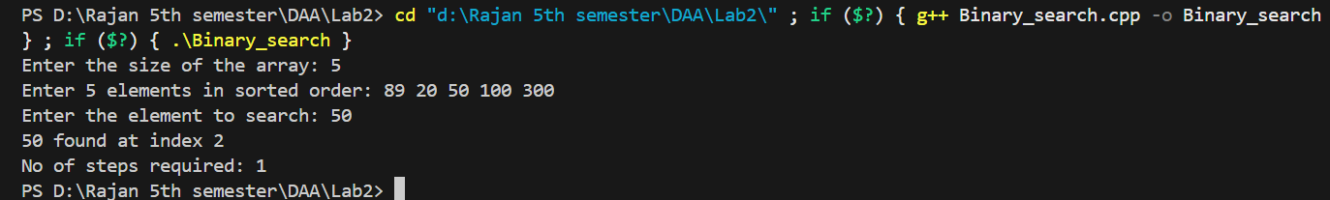

**Minmax Output:**



**Merge Sort Output:**

